**TechCare**

**Table of Contents :**

* **1. Introduction**
* **2. Objectives**
* **3. System Analysis**
  + **Problem definition**
  + **Preliminary Investigation**
  + **Feasibility Study**

**4. Scope identified**

* **5. Features**
* **6. Class Overview**
* **7. Database Schema**
* **8. ER diagram**
* **9. Coding**
* **10. Output**
* **11. Testing**
* **12. Usage**
* **13. Conclusion**
* **14. Future Application of the project**
* **15. Bibliography**

**1. Introduction**

**TechCare** is an innovative console-based platform developed to streamline the management of hardware and software support within an organization. Designed using Java, MySQL, JDBC, and Spring Tool Suite (Eclipse), TechCare enables employees to report technical issues efficiently, allows engineers to manage and resolve these issues, and provides oversight to the Head of Department (HOD). This system ensures that technical problems are addressed promptly, minimizing downtime and enhancing productivity.

**Importance of IT Support Systems**: In today’s digital era, organizations rely heavily on IT infrastructure. Any downtime or malfunction can severely impact business operations. TechCare addresses this by providing a structured and efficient support system, ensuring that hardware and software issues are managed effectively.

**Summary of Features**:

* **HOD**: Manage engineers and oversee problem resolution.
* **Engineers**: Address assigned problems and update their status.
* **Employees**: Report issues and track their resolution status.

**2. Objectives**

**Goals of TechCare**:

* Provide a 24/7 accessible platform for reporting and managing IT issues.
* Enhance the efficiency and effectiveness of technical support within an organization.
* Minimize downtime caused by hardware and software problems.

**Key Problems Addressed**:

* Lack of a centralized system for reporting and tracking technical issues.
* Inefficient assignment and resolution of problems.
* Difficulty in monitoring the status and history of reported issues.

**Expected Benefits**:

* Streamlined process for reporting and managing IT issues.
* Improved accountability and transparency in problem resolution.
* Enhanced productivity due to reduced downtime.

**3. System Analysis**

**Problem Definition**

Employees frequently encounter hardware and software issues that disrupt their workflow. These problems often lead to significant downtime, affecting productivity and business operations. Without a centralized system, reporting and managing these issues become chaotic, with no clear oversight or accountability.

**Preliminary Investigation**

To address these challenges, we conducted a preliminary investigation:

* **Data Gathering**: Collected data on the frequency and types of IT issues reported.
* **Interviews**: Conducted interviews with employees, engineers, and HODs to understand their pain points.
* **Benchmarking**: Analyzed existing support systems and their shortcomings.

**Feasibility Study**

**Technical Feasibility**:

* **Java, MySQL, and JDBC**: Well-supported technologies suitable for developing a robust console-based system.
* **Spring Tool Suite (Eclipse)**: Provides a comprehensive environment for Java development.

**Economic Feasibility**:

* Minimal costs involved as the project utilizes open-source technologies and existing infrastructure.
* Potential for significant cost savings through reduced downtime and improved efficiency.

**Operational Feasibility**:

* The system can be easily integrated into the existing workflow.
* User-friendly interface ensures quick adoption by employees, engineers, and HODs.

**4. Scope Identified**

**User Roles and Responsibilities**:

* **HOD**: Register and manage engineers, oversee all reported problems, and assign issues to engineers.
* **Engineers**: View and resolve assigned problems, update their status, and manage their account.
* **Employees**: Register and track hardware/software issues, view problem status, and manage their account.

**System Boundaries**:

* Only registered users (HOD, engineers, employees) can access the system.
* The system handles problem reporting and resolution for hardware and software issues within the organization.

**Limitations**:

* The system is currently console-based, which may limit its usability compared to a graphical interface.
* It is designed for internal use within the organization and does not support external user access.

**5. Features**

**HOD Features:**

* **Login**: Secure access using predefined credentials.
* **Engineer Management**: Register new engineers with specific roles (hardware/software), view all engineers, and delete engineers.
* **Problem Oversight**: View all reported problems and assign them to appropriate engineers.

**Engineer Features:**

* **Login**: Access using credentials provided by the HOD.
* **Problem Management**: View and update the status of assigned problems, and maintain a record of addressed issues.
* **Account Management**: Change password to ensure secure access.

**Employee Features:**

* **Self-Registration**: Create an account with a username and password.
* **Problem Reporting**: Report hardware/software issues and generate a unique complaint ID.
* **Status Tracking**: Check the status of reported issues and view the assigned engineer.
* **Complaint History**: View a complete history of all complaints raised.
* **Password Management**: Change password for secure access.

**6. Class Overview**

### HOD Class

The HOD class represents the Head of Department in the TechCare system. It includes attributes such as HOD name, username, and password. These attributes enable secure login and management of engineering department operations.

### EngineeringDepartment Class

The EngineeringDepartment class defines departments within the organization responsible for handling hardware and software support. It includes attributes such as department ID and department name, facilitating departmental management and assignment of support tasks.

### Engineer Class

The Engineer class represents engineers responsible for resolving hardware and software issues reported within the TechCare system. It includes attributes such as engineer ID, name, username, password, and department name. These attributes enable engineer authentication, task assignment, and performance tracking.

### Employee Class

The Employee class represents employees within the organization who report hardware and software issues to the TechCare system. It includes attributes such as employee ID, name, username, password, and department ID. These attributes facilitate employee authentication, issue reporting, and status tracking.

### Complaints Class

The Complaints class manages hardware and software issues reported by employees within the organization. It includes attributes such as complaint ID, complaint type, status, raised date, resolution date, employee ID, and engineer ID. These attributes enable tracking of issue lifecycle, assignment to engineers, and resolution status updates.

### TechCareDBConnection Class

The TechCareDBConnection class manages database connectivity for the TechCare system using JDBC. It includes attributes such as JDBC driver, database URL, username, and password. These attributes facilitate secure and efficient communication with the underlying database management system.

### HODDAO Class

The HODDAO class serves as a Data Access Object responsible for handling database operations related to HODs within the TechCare system. It includes methods for inserting, updating, deleting, and querying HOD records based on HOD username. These methods encapsulate database interactions, ensuring secure management of HOD credentials and department operations.

### EngineerDAO Class

The EngineerDAO class manages database operations related to engineers within the TechCare system. It includes methods for inserting, updating, deleting, and querying engineer records based on engineer username. These methods support engineer authentication, task assignment, and performance evaluation, ensuring efficient management of engineering resources.

### EmployeeDAO Class

The EmployeeDAO class handles database operations concerning employees within the TechCare system. It includes methods for inserting, updating, deleting, and querying employee records based on employee username. These methods facilitate employee authentication, issue reporting, and status tracking, supporting effective communication and problem resolution.

### ComplaintsDAO Class

The ComplaintsDAO class manages database operations related to complaints (hardware and software issues) reported within the TechCare system. It includes methods for inserting, updating, deleting, and querying complaint records based on complaint ID and employee ID. These methods facilitate issue tracking, assignment to engineers, and resolution status updates, ensuring timely and effective support services.

**7. Database Schema**

### 1. HOD Table

|  |  |  |
| --- | --- | --- |
| **Column** | **Data Type** | **Constraint** |
| email | VARCHAR(50) | PRIMARY KEY |
| name | VARCHAR(50) |  |
| password | VARCHAR(50) |  |

### 2. ProblemLog Table

|  |  |  |
| --- | --- | --- |
| **Column** | **Data Type** | **Constraint** |
| LogID | INT | PRIMARY KEY |
| empID | INT | FOREIGN KEY |
| probID | INT | FOREIGN KEY |
| engID | INT | FOREIGNKEY |
| status | VARCHAR(11) |  |
| LaunchedOn | DATE |  |
| StartedWorking | DATE |  |
| ClosedOn | DATE |  |

### 3. Engineer Table

|  |  |  |
| --- | --- | --- |
| **Column** | **Data Type** | **Constraint** |
| engID | INT | PRIMARY KEY |
| name | VARCHAR(30) |  |
| email | VARCHAR(30) | UNIQUE |
| password | VARCHAR(30) |  |
| category | VARCHAR(11) |  |

### 4. Employee Table

|  |  |  |
| --- | --- | --- |
| **Column** | **Data Type** | **Constraint** |
| empID | INT | PRIMARY KEY |
| name | VARCHAR(50) |  |
| email | VARCHAR(50) | UNIQUE |
| password | VARCHAR(20) |  |
| status | VARCHAR(11) |  |

### 5. Problem Table

|  |  |  |
| --- | --- | --- |
| **Column** | **Data Type** | **Constraint** |
| probID | INT | PRIMARY KEY |
| probDesc | VARCHAR(300) |  |
| category | VARCHAR(11) | FOREIGN KEY Patients(PatientID) |
| priority | VARCHAR(10) |  |

### Architecture Overview

TechCare follows a layered architecture:

* **Presentation Layer**: Console-based interface for user interactions.
* **Business Logic Layer**: Core logic for managing user roles, problem reporting, and assignment.
* **Data Access Layer**: Handles interactions with the MySQL database using JDBC.

**Database Design**

The system’s database is designed to store:

* **User Information**: Details of HODs, engineers, and employees.
* **Problem Records**: Details of reported problems, including status, assigned engineer, and history.
* **Login Credentials**: Secure storage of usernames and passwords.

**User Interface Design**

Although TechCare is console-based, the interface is designed to be intuitive and user-friendly, ensuring smooth navigation and interaction for all users.

**8. ER diagram**

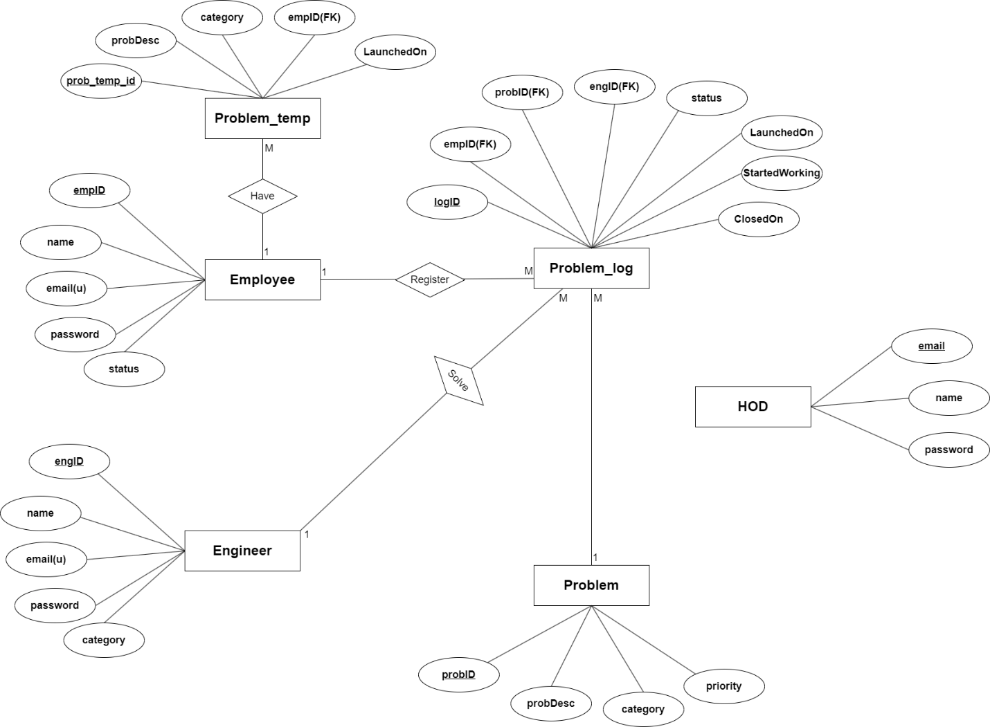

**9. Coding**

Main.java

package com.ohasss.main;

import java.util.Scanner;

import com.ohasss.usecases.ApproveAnEmployee;

import com.ohasss.usecases.AssignAComplaintToAnEngineer;

import com.ohasss.usecases.ChangePassword;

import com.ohasss.usecases.ChangePasswordEmp;

import com.ohasss.usecases.GetAndSetNewProblem;

import com.ohasss.usecases.GetComplaintHistory;

import com.ohasss.usecases.LoginEmployee;

import com.ohasss.usecases.LoginEngineer;

import com.ohasss.usecases.LoginHOD;

import com.ohasss.usecases.RegisterAComplaint;

import com.ohasss.usecases.RegisterAnEngineer;

import com.ohasss.usecases.RegisterEmployee;

import com.ohasss.usecases.RemoveAnEngineer;

import com.ohasss.usecases.ShowAllComplaints;

import com.ohasss.usecases.ShowAllEmployees;

import com.ohasss.usecases.ShowAllEngineers;

import com.ohasss.usecases.ShowComplaintStatus;

import com.ohasss.usecases.ShowProblemsAssigned;

import com.ohasss.usecases.UpdateProblemStatus;

public class Main {

public static void main(String[] args) {

Scanner sc = new Scanner(System.in);

System.out.println("==========================================================\n"

+ "| Welcome To Online Hardware And Software Support System |\n"

+ "==========================================================\n");

boolean i1 = true;

while(i1) {

System.out.println("\n\n"

+ "________________________________\n"

+ "| |\n"

+ "| Please Select An User |\n"

+ "| 1 - HOD |\n"

+ "| 2 - Engineer |\n"

+ "| 3 - Employee |\n"

+ "| 4 - Exit |\n"

+ "|______________________________|\n");

System.out.print("Enter Your Choice : ");

int ch1 = sc.nextInt();

switch(ch1) {

case 1: System.out.println("\n\nHOD Login");

System.out.println("=========");

if(LoginHOD.logHOD()) {

boolean i2 = true;

while (i2) {

System.out.println("\n\n"

+ "______________________________________________\n"

+ "| |\n"

+ "| Please Select Correct Option |\n"

+ "| 1 - Register An Engineer |\n"

+ "| 2 - Show All Engineers |\n"

+ "| 3 - Remove An Engineer |\n"

+ "| 4 - Show All Complaints |\n"

+ "| 5 - Assign A Complaint To An Engineer |\n"

+ "| 6 - Set Priority Of A Complaint |\n"

+ "| 7 - Approve An Employee |\n"

+ "| 8 - Show All Employees |\n" // New option

+ "| 9 - Exit |\n"

+ "|____________________________________________|\n");

System.out.print("Enter Your Choice : ");

int ch2 = sc.nextInt();

switch (ch2) {

case 1:

System.out.println("\n\nRegister An Engineer");

System.out.println("====================");

RegisterAnEngineer.regAnEngg();

break;

case 2:

System.out.println("\n\nShow All Engineers");

System.out.println("==================");

ShowAllEngineers.showAllEngg();

break;

case 3:

System.out.println("\n\nRemove An Engineer");

System.out.println("==================");

RemoveAnEngineer.removeAnEngg();

break;

case 4:

System.out.println("\n\nShow All Complaints");

System.out.println("===================");

ShowAllComplaints.showAllCompl();

break;

case 5:

System.out.println("\n\nAssign A Complaint To An Engineer");

System.out.println("================================");

AssignAComplaintToAnEngineer.assignAComplToAnEngg();

break;

case 6:

System.out.println("\n\nSet Priority Of A Complaint");

System.out.println("===========================");

GetAndSetNewProblem.setPriorityOfAComp();

break;

case 7:

System.out.println("\n\nApprove An Employee");

System.out.println("===================");

ApproveAnEmployee.approveAnEmp();

break;

case 8: // New case for showing all employees

System.out.println("\n\nShow All Employees");

System.out.println("==================");

ShowAllEmployees.showAllEmp();

break;

case 9:

i2 = false;

break;

default:

System.out.println("\n\nWrong Choice...");

}

}

}

break;

case 2: System.out.println("\n\nEngineer Login");

System.out.println("==============");

int engID = LoginEngineer.loginEngg();

if(engID != 0) {

boolean i2 = true;

while(i2) {

System.out.println("\n\n"

+ "______________________________________________\n"

+ "| |\n"

+ "| Please Select Correct Option |\n"

+ "| 1 - Show All Complaints Assigned By HOD |\n"

+ "| 2 - Update Complaint Status |\n"

+ "| 3 - Show All Complaints Attended By Him |\n"

+ "| 4 - Change Password |\n"

+ "| 5 - Exit |\n"

+ "|____________________________________________|\n");

System.out.print("Enter Your Choice : ");

int ch2 = sc.nextInt();

switch(ch2) {

case 1:

System.out.println("\n\nShow All Complaints Assigned By HOD");

System.out.println("===================================");

ShowProblemsAssigned.showProbAssign(engID);

break;

case 2:

System.out.println("\n\nUpdate Complaint Status");

System.out.println("=======================");

UpdateProblemStatus.updateProbStat(engID);

break;

case 3:

System.out.println("\n\nShow All Complaints Attended By Him");

System.out.println("===================================");

ShowProblemsAssigned.showProbAssign(engID);

break;

case 4:

System.out.println("\n\nChange Password");

System.out.println("===============");

ChangePassword.changePass(engID);

break;

case 5:

i2 = false;

break;

default:

System.out.println("\n\nWrong Choice...");

}

}

}

break;

case 3:

boolean i2 = true;

while(i2) {

System.out.println("\n\n"

+ "________________________________\n"

+ "| |\n"

+ "| Please Select Correct Option |\n"

+ "| 1 - Register |\n"

+ "| 2 - Login |\n"

+ "| 3 - Exit |\n"

+ "|______________________________|\n");

System.out.print("Enter Your Choice : ");

int ch2 = sc.nextInt();

switch(ch2) {

case 1:

System.out.println("\n\nRegister Employee");

System.out.println("=================");

RegisterEmployee.registerEmp();

break;

case 2:

System.out.println("\n\nLogin Employee");

System.out.println("==============");

int empID = LoginEmployee.loginEmp();

if(empID != 0) {

boolean i3 = true;

while(i3) {

System.out.println("\n\n"

+ "________________________________\n"

+ "| |\n"

+ "| Please Select Correct Option |\n"

+ "| 1 - Register A Complaint |\n"

+ "| 2 - Show Complaint Status |\n"

+ "| 3 - Complaint History |\n"

+ "| 4 - Change Password |\n"

+ "| 5 - Exit |\n"

+ "|______________________________|\n");

System.out.print("Enter Your Choice : ");

int ch3 = sc.nextInt();

switch(ch3) {

case 1:

System.out.println("\n\nRegister A Complaint"

+ "\n====================");

RegisterAComplaint.registerAComp(empID);

break;

case 2:

System.out.println("\n\nShow Complaint Status"

+ "\n=====================");

ShowComplaintStatus.showCompStat(empID);

break;

case 3:

System.out.println("\n\nComplaint History"

+ "\n=================");

GetComplaintHistory.getCompHist(empID);

break;

case 4:

System.out.println("\n\nChange Password"

+ "\n===============");

ChangePasswordEmp.changePassEmp(empID);

break;

case 5:

i3 = false;

break;

default:

System.out.println("\n\nWrong Choice...");

}

}

}

break;

case 3:

i2 = false;

break;

default:

System.out.println("\n\nWrong Choice...");

}

}

break;

case 4: System.out.println("\n\nThank You For Using Our Application...");

i1 = false;

break;

default: System.out.println("\n\nWrong Choice...");

}

}

sc.close();

}

}

**10. Output**

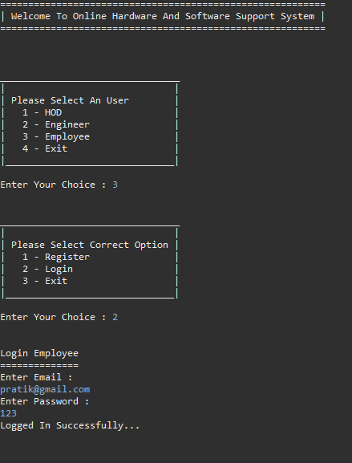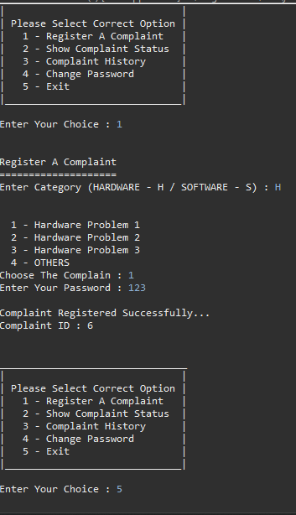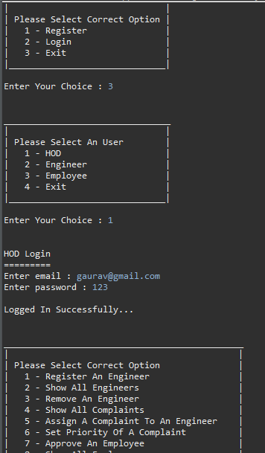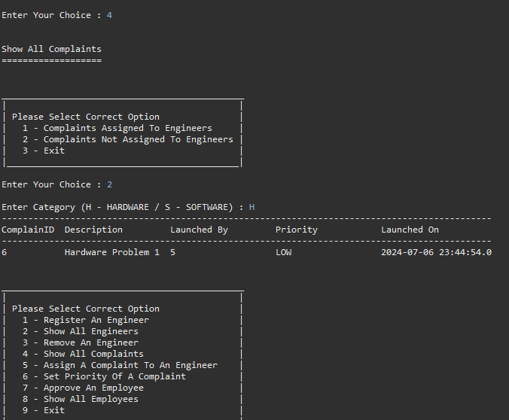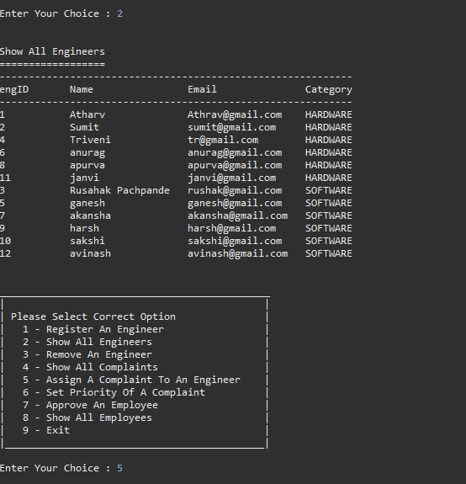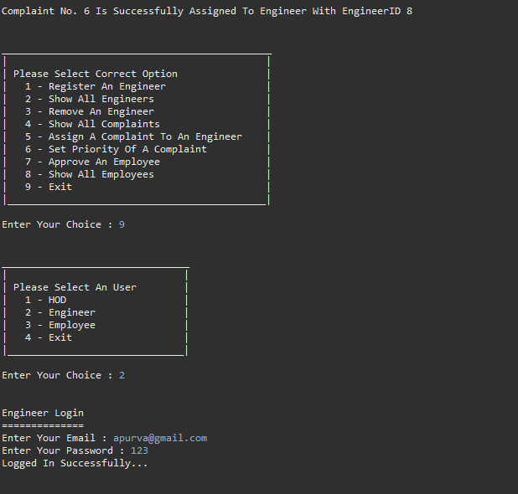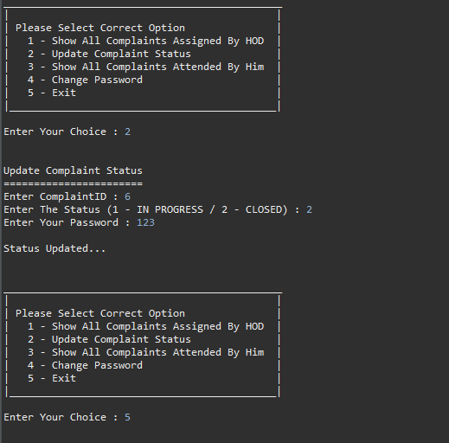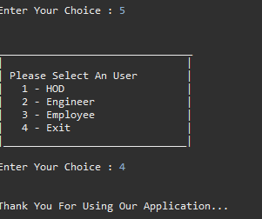

**11. Testing**

1. **User Authentication and Access Control:**
   * Test user login functionality with valid credentials.
   * Test user login functionality with invalid credentials.
   * Verify access control for different user roles (HOD, Engineer, Employee).
   * Ensure proper error messages are displayed for login failures.
2. **Engineer and Employee Management:**
   * Test registration of Engineers and Employees with valid data.
   * Test registration process with invalid data (e.g., duplicate username, missing fields).
   * Verify that a unique ID is generated for each registration.
   * Ensure proper validation for registration inputs.
3. **Complaints and Issues Management:**
   * Test registration of complaints/issues by Employees.
   * Verify that complaints/issues are assigned to Engineers correctly.
   * Test updating of issue statuses by Engineers.
   * Ensure proper notification and communication channels for issue updates.
4. **Department Management:**
   * Test creation of new departments by HOD.
   * Verify that departments are managed correctly in the system.
   * Test assigning Engineers to departments.
   * Ensure proper validation and error handling for department operations.
5. **Database Operations:**
   * Test CRUD operations for all main entities (HOD, Engineer, Employee, Department, Complaints).
   * Verify data integrity across related entities (foreign key constraints).
   * Test database connection stability and error handling scenarios.
   * Ensure backup and restore procedures are functional and tested periodically.
6. **Security and Access Control:**
   * Test data encryption methods for sensitive information (e.g., passwords, complaint details).
   * Verify role-based access control (RBAC) for system functionalities.
   * Test system resilience against common security threats (e.g., SQL injection, XSS attacks).
   * Ensure compliance with relevant data protection regulations (e.g., GDPR).
7. **Performance and Scalability:**
   * Test system performance under various load conditions (e.g., peak usage times).
   * Verify scalability by simulating increased user and data volume.
   * Test response times for critical operations (e.g., complaint registration, issue resolution).
   * Ensure efficient resource utilization to optimize system performance.
8. **User Interface and User Experience (UI/UX):**
   * Conduct usability testing for intuitive navigation and user interaction.
   * Verify accessibility standards compliance (e.g., WCAG) for diverse user needs.
   * Test responsiveness across different devices and screen sizes.
   * Ensure consistent and clear feedback messages throughout the application.
9. **Integration and API Testing:**
   * Test integration with external systems or APIs (if applicable).
   * Verify data exchange and compatibility with third-party tools.
   * Conduct endpoint testing for APIs used within the system.
   * Ensure proper error handling and validation of API responses.
10. **Documentation and Reporting:**
    * Test generation and accessibility of reports (e.g., complaint status, engineer performance).
    * Verify accuracy and completeness of system documentation (user manuals, technical guides).
    * Conduct usability testing for documentation accessibility and readability.
    * Ensure timely updates and maintenance of all project documentation.

**12. Usage**

• **User Authentication and Access Control:**

* **Login and Authentication:**
  + Users (HOD, Engineer, Employee) should log in using their respective credentials (username and password).
  + Ensure credentials are kept confidential and not shared with unauthorized individuals.
* **Access Control:**
  + HOD can access all functionalities including engineer management, complaint assignment, and system administration.
  + Engineers can view assigned complaints and update their status accordingly.
  + Employees can register complaints and track their status within the system.

• **Engineer and Employee Management:**

* **Engineer Registration:**
  + HOD registers new engineers by providing unique usernames and passwords.
  + Assign engineers to specific departments (Hardware or Software) based on their expertise.
* **Employee Registration:**
  + Employees register themselves with unique usernames and passwords to access the system.
  + Employees can update their profile information such as contact details and department affiliation.

• **Complaints and Issues Management:**

* **Registering Complaints:**
  + Employees submit complaints regarding hardware or software issues they encounter.
  + Each complaint is assigned a unique complaint ID for tracking purposes.
* **Assigning and Managing Complaints:**
  + HOD assigns complaints to engineers based on workload and expertise.
  + Engineers update the status of assigned complaints (e.g., in progress, resolved) as they work on them.
  + Ensure timely resolution and effective communication with employees regarding complaint status updates.

• **Department Management:**

* **Creating and Managing Departments:**
  + HOD creates new departments (Hardware or Software) as per organizational needs.
  + Manage department details such as department name and assigned engineers.

• **Database Operations and Data Management:**

* **CRUD Operations:**
  + Perform CRUD operations on main entities (HOD, Engineer, Employee, Department, Complaints) using JDBC.
  + Ensure data integrity and consistency across related tables.
* **Backup and Restore Procedures:**
  + Regularly backup database to prevent data loss in case of system failures.
  + Implement restore procedures to recover data from backups as needed.

• **Security and Access Control:**

* **Data Security Measures:**
  + Implement encryption methods to protect sensitive data (e.g., passwords, complaint details) stored in the database.
  + Define and enforce strict access control policies based on user roles (HOD, Engineer, Employee).
* **Security Best Practices:**
  + Regularly update system and database security patches to mitigate vulnerabilities.
  + Conduct security audits and penetration testing to identify and address potential security risks.

• **Integration and Compatibility:**

* **Database Compatibility:**
  + Ensure compatibility with JDBC-supported databases (e.g., MySQL, Oracle) for seamless data interaction.
  + Integrate with other internal systems or applications used within the organization (e.g., IT management tools).
* **APIs and Data Exchange:**
  + Provide APIs or interfaces for integration with external systems, facilitating data exchange and synchronization.

• **Error Handling and Logging:**

* **Error Handling Mechanisms:**
  + Implement robust error handling to gracefully manage exceptions and unexpected scenarios.
  + Log system activities, user interactions, and errors for auditing and troubleshooting purposes.
* **User Guidance:**
  + Display informative error messages to users when errors occur, providing guidance on resolution steps.

• **User Interface and Usability:**

* **Intuitive User Interface:**
  + Design a user-friendly interface with intuitive navigation and clear menu options.
  + Include helpful features such as search functionality and tooltips to assist users in navigating the system.
* **Usability Testing:**
  + Conduct usability testing to gather feedback from users and refine the interface based on user experience.

• **Performance Optimization:**

* **System Performance:**
  + Optimize database queries and transactions to ensure efficient data retrieval and manipulation.
  + Implement caching mechanisms to improve system responsiveness and reduce load times.
* **Monitoring and Optimization:**
  + Monitor system performance metrics (e.g., response times, resource utilization) and optimize accordingly.
  + Identify and address performance bottlenecks to maintain smooth system operation under varying workloads.

**13. Conclusion**

TechCare successfully addresses the critical need for a structured and efficient support system within organizations. By providing a centralized platform for reporting, managing, and resolving IT issues, TechCare enhances productivity, reduces downtime, and ensures that technical problems are handled promptly. The project has demonstrated significant improvements in how organizations manage their IT support processes, leading to better operational efficiency and user satisfaction.

**14. Future Application of the project**

**Potential Enhancements**

* **Graphical User Interface (GUI)**: Develop a web-based or desktop GUI to enhance user experience.
* **Mobile Support**: Create mobile applications for easier access and problem reporting.
* **AI and Automation**: Integrate AI to automatically categorize and assign problems, and provide predictive maintenance suggestions.

**Expansion to Other Domains**

* Extend the system to support other organizational functions like HR, finance, or customer support.

**Integration with Other Systems**

* Integrate with existing ERP or CRM systems to provide a more comprehensive support solution.

**15. Bibliography**

### References and Sources

* **Java Documentation**: [Oracle Java SE Documentation](https://docs.oracle.com/en/java/javase/).
* **MySQL Documentation**: [MySQL Reference Manual](https://dev.mysql.com/doc/refman/8.0/en/).
* **JDBC Guide**: [Java JDBC API Guide](https://docs.oracle.com/javase/tutorial/jdbc/).

### Tools and Technologies Used

* **Java**: Programming language used for system development.
* **MySQL**: Database management system for data storage.
* **JDBC**: API for database connectivity.
* **Spring Tool Suite (Eclipse)**: Integrated development environment for Java.